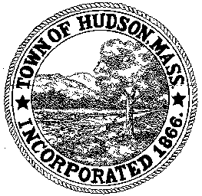

CONSERVATION COMMISSION
78 Main Street, Hudson, MA 01749
(978) 562-2020

Paul Byrne, Chairman W. Minot Wood, Vice Chairman David Esteves, Member

Terrence Joyce, Member Leif Longtine, Member Joseph Rodrigues, Member Al Tashian, Member

Meeting Agenda
August 19, 2010 7:00 P.M.

- Preliminaries
  - Open Meeting
  - Roll Call

2.0 Hearings and Appointments
2.1 22 Manning Street

2.2 RDA 398
Applicant: Jeffrey Hillis
Location: 5 Cold Springs Lane
Project Description: construction of a 20’ x 25’ addition and upgrade to the septic system

2.3 RDA 400
Applicant: Dion DePrisco
Location: 44 Lakeside Avenue
Project Description: rebuilding and repair of an existing 70”x 2.5’ stone wall

2.4 DEP 190-544
Applicant: Charles Freeman
Location: 35 Worcester Avenue
Project Description: Request for Certificate of Compliance

2.5 DEP 190-439
Applicant: Paul Giannetti
Location: Coolidge Street Lot 56
Project Description: Request for Certificate of Compliance

2.6 Update on 455 River Road

2.7 DEP 190-471
Applicant: Neal Fossile
Location: 3 Hilltop
Project Description: Request for Certificate of Compliance

2.8 DEP 190-534
Request for extension
Applicant: Riverside Estates Condominium Association
Location: 125 Chapin Road

2.9 DEP 190-549
Discussion of Conditions/Sign Order of Conditions
Location: Rolling Lane

2.10 DEP 190-551
Applicant: Martin Libby
Location: 35 Worcester Avenue
Sign Order of Conditions

2.10 Review Conservation Restriction for Fossile Property

3.0 General Business
3.0.1 Voucher 080210 $491.70
3.0.2 Voucher 081910 $4125.00

3.1 New Business

  - Old Business
3.2.1 54 Lakeshore Drive – trees
3.2.2 3 Oneida Place - trees

- Executive Session
For the purpose of discussing pending litigation

